TEST SHEET
See the documents below and answer the following?

What is wrong with this adhar card?
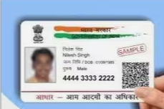

What is wrong with this PAN card?
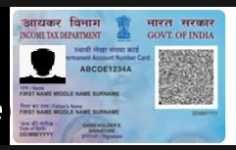
Assuming today’s date is 01/04/2024, What is wrong with this electric bill? What a correct electric bill should be like, give a description of correct electric bill

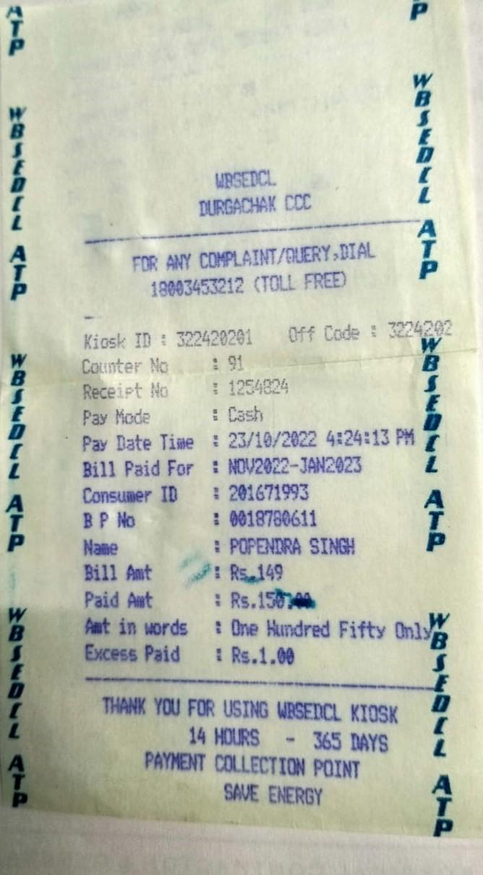

What is wrong with this pic?



What is wrong with this Bank Statement?

